HOME PAGE

- Animation

- “Proven outcomes, Faster than ever”

GENERIC APPROACH
SCAELEIQ 35% More Cost-Effective

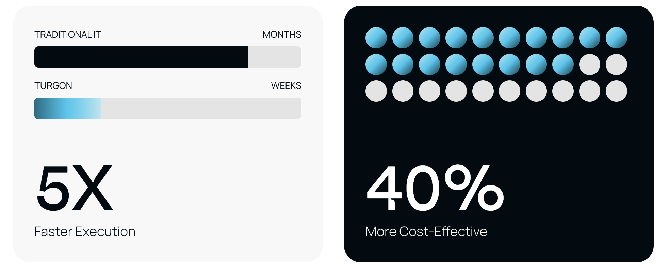

- “Your Data Platform, Always Learning. Always Live"

Image DATA ORGANIZATION
Stop moving data. Start modernizing it

- DATA GOVERNANCE

Stop letting bad data shape your business outcomes. IMAGE

- DECISION INTELLIGENCE
Solutions that supports all use cases
IMAGE

AI Agents + Domain Assistants + AI Helpers

- True Clients. True Results

Abbott Foshpa SHI

Footer:
sales@scaeleiq.com Privacy Policy © 2026. Powered and secured by SCAELEIQ

